The earnings data on the CPS interface from UCPath is taken from the Salary Detail table in Labor Ledger. The Salary Detail table does not include earnings for vacation leave taken. Since vacation leave taken is funded from a central pool, related data is passed to the campus G/L system on the Deduction Detail table instead. The Deduction Detail table does not include data which is critical for earnings stored in CPS, such as the number of hours paid or the earned date.
The CPS interfaces lead for UCPath created special logic to derive vacation leave earnings using some staging tables in UCPath that are the source for Labor Ledger tables. This derived vacation earnings data is unofficial and may not be 100% accurate; for example, it does not include vacation leave transactions which underwent a Salary Cost Transfer since SCT’s are not included in the staging table that is used as a source. This means that you may see Salary Cost Transfer debits and credits for base pay and other types of pay, but no corresponding transaction for vacation earnings.
Example 1:
Here is a simple example of a salaried/monthly employee who reported 40 hours of vacation leave for January 2016 – the timesheet was submitted in February and reflected in the March 1st paycheck:
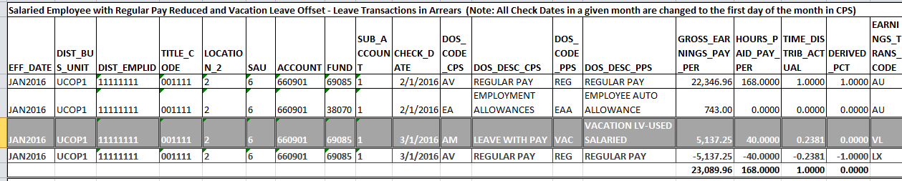
The dark-highlighted row with white text is a derived vacation earnings record. Derived Vacation earnings records will all have an Earnings_Transaction_Code of VL.
The derived Vacation earnings record offsets the REG pay record directly below it. The total Hours_Paid_Pay_Per (168.0000) and Time_Distrib_Actual (1.0000) show that the employee was paid 100% of his/her full-time salary for the month of January. Since monthly employees report leave in arrears, Vacation leave was paid on March 1st while Regular Pay and Auto Allowance were paid on February 1st.
Derived_Pct comes from the Labor Ledger and currently is not accurate. Use Time_Distrib_Actual for actual FTE. This has been calculated in CPS by dividing the number of hours associated with the record by the number of standard working hours in the earnings month.
Example 2:
Here is a simple example of a salaried/monthly employee who reported 8 hours of vacation leave and 8 hours of jury duty leave for January 2016 – the timesheet was submitted in February and reflected in the March 1st paycheck:
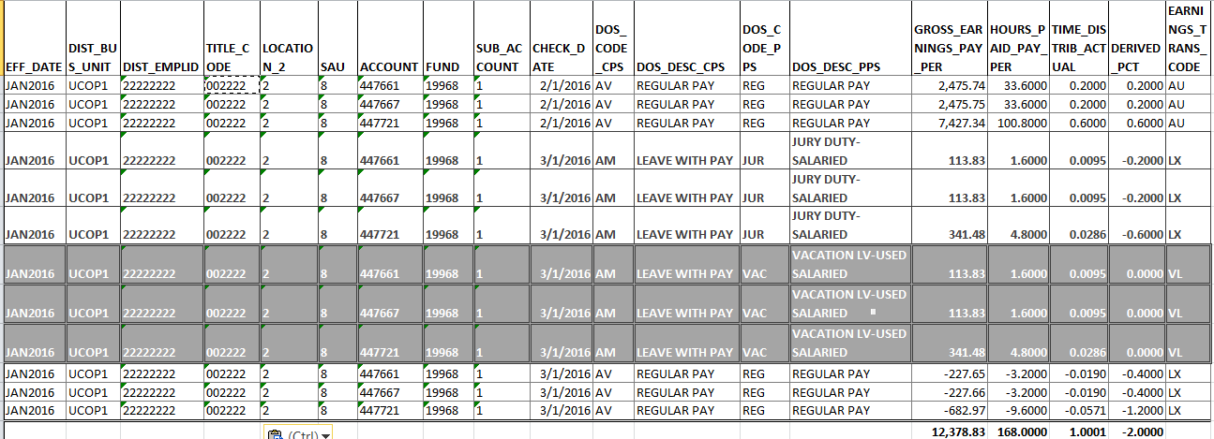
Again, the dark-highlighted row with white text is a derived vacation earnings record. Derived Vacation earnings records will all have an Earnings_Transaction_Code of VL.
The derived Vacation earnings records must be combined with the Jury duty records above them in order to offset the REG pay records directly below them. The total Hours_Paid_Pay_Per (168.0000) and Time_Distrib_Actual (1.0001) show that the employee was paid 100% of his/her full-time salary for the month of January.
This employee is paid from 3 different accounts so there are three records for each transaction.
Regular Pay was paid on February 1st and leave payments were processed on the March 1st paycheck.
Example 3:
Here is a simple example of an hourly/biweekly employee who submitted his/her timesheet for biweekly pay periods ending March 12, March 26, and April 9. Each of these pay periods includes some work days in March:
2/28 – 3/12 – includes 9 working days in March – 72 hours
3/13 – 3/26 – includes 10 working days in March – 80 hours
3/27 – 4/9 – includes 4 working days in March – 32 hours
Total March working hours = 184
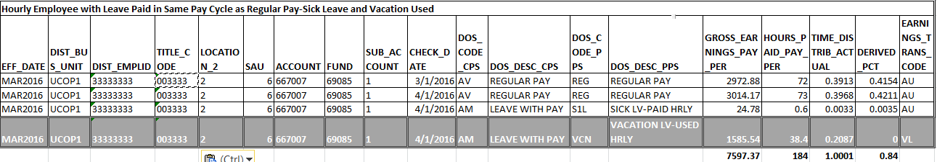

Since biweekly employees must turn in a timesheet before being paid, there is no need to create REG pay credits to offset leave earnings records. The REG pay records simply contain the number of REG hours paid.
This employee reported 1.5 hours of sick leave and 16 hours of vacation for the pay period between March 27th and April 9th. Since 40% of the work days in that pay period fell in the month of March, 40% of these leave hours were assigned to the earned month of March in CPS - .6 hours of sick leave and 6.4 hours of vacation. The other 32 hours of vacation leave were taken in the pay period from 3/13 to 3/26, so 100% of those earnings were assigned to the month of March.
Note that CPS assigns a check date of the 1st day of the month to all check dates which fall within that month. This is to allow us to summarize the data by the month the check was issued, therefore saving some space. The CPS database has gotten so large that data retrieval can be extremely slow.
Example 4:
This is an example of an hourly/biweekly employee who did not work full-time in May 2016 and took some leave hours that were not covered by any type of paid leave. It is not necessary in UCPath to account for all possible working hours for Hourly employees, so there are no Leave Without Pay transactions created.
Each of these pay periods includes some work days in May:
4/23 – 5/7 – includes 5 working days in May – 40 hours
5/8 – 5/21 – includes 10 working days in May – 80 hours
5/22 – 6/4 – includes 7 working days in May – 56 hours
Total May working hours = 176
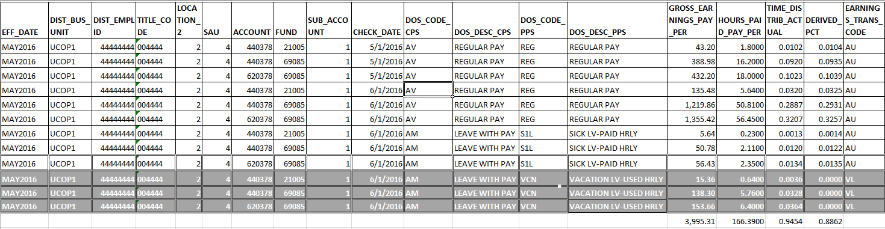

This employee was paid Regular Pay for 36 hours in the pay period from 4/23 to 5/7 – 4 hours are not accounted for.
The employee was paid Regular pay for 112.9 hours worked in May during the other two pay periods, plus he or she received sick leave earnings for 4.69 hours and vacation leave for 12.8 hours for those pay periods. 5.61 hours are not accounted for during these pay periods.
Example 5:
Here is a salaried/monthly employee who took some unpaid leave in May:

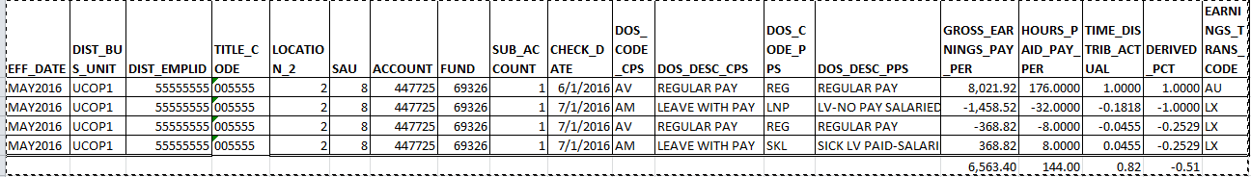
This employee had 8 hours of sick leave and 32 hours of unpaid leave, which brings the total number of hours worked down to 144 and the total FTE to .82.
Note that the CPS DOS code is AM – Leave With Pay. This sounds counterintuitive but using this same CPS DOS code to represent both paid leave and unpaid leave ensures that the negative hours, earnings, and FTE for salaried employees are included in the calculation of base pay. If we excluded this record from base pay by assigning a CPS DOS Code of “LV”, it would appear that the employee had received full pay for the month.
The “LV” CPS DOS Code is restricted to leave which is added to base pay, such as Compensatory Time payout or Terminal Vacation Pay.
This employee had no paid vacation leave during this month so there are no derived vacation leave earnings records.

